**APPLICATION BUILDING**

**RUN THE APPLICATION**

**TEAM ID : PNT2022TMID03082**

Home Page:

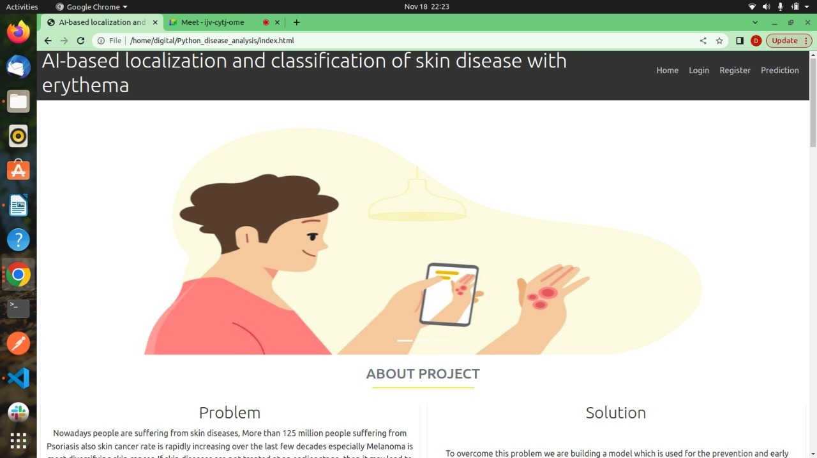

Register:

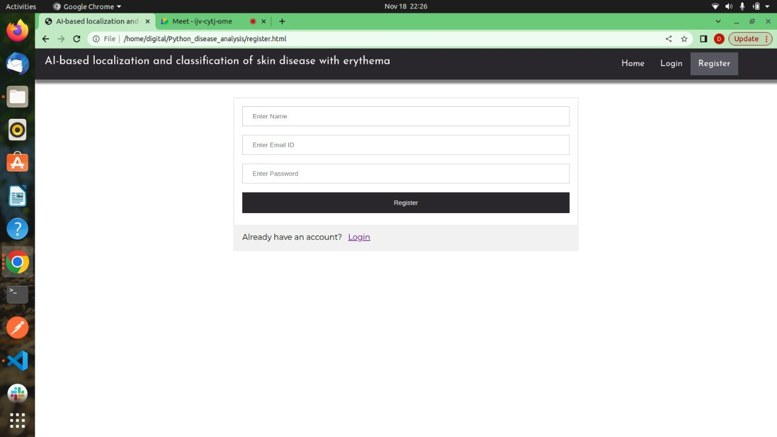

Login:

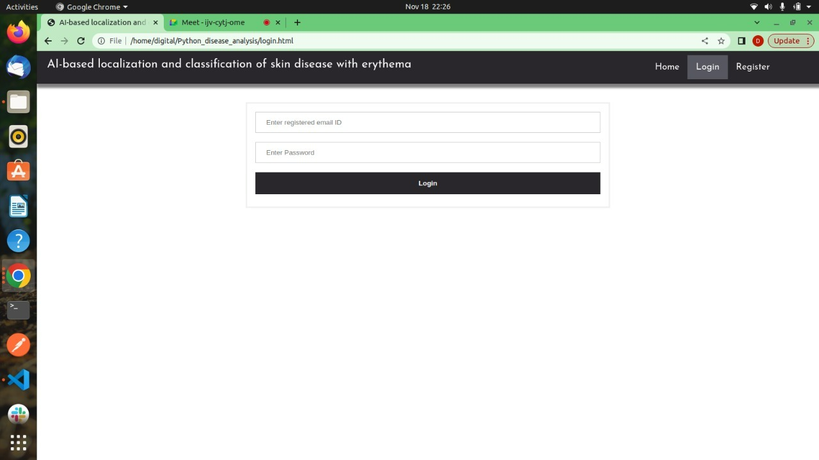

Skin Disease Detection:

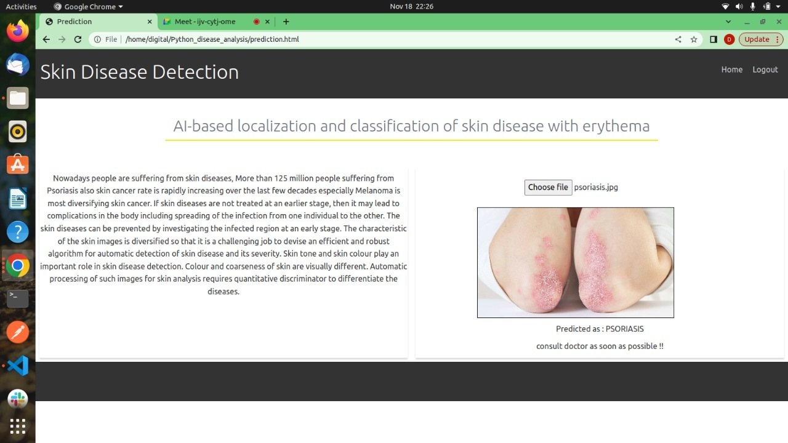

Logout:

